Here we have utilized Workspace API to achieve this functionality <https://developer.salesforce.com/docs/component-library/bundle/lightning:workspaceAPI/documentation>

Here you can find the links of the needed files and below are the explanations [Html file](closeSubTab/closeSubTab.html), [JS file](closeSubTab/closeSubTab.js), [CSS file](closeSubTab/closeSubTab.css)

This is the UI example where we have a flow open as a subtab with a close button on click of which it will close the sub Tab and redirect to contact record page(from where it was initiated)

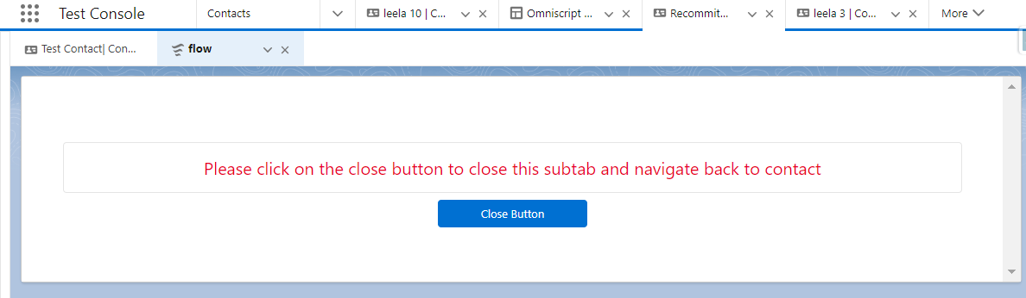

Now lets get a walkthrough to the code and understand how it is implemented

In HTML we have a button named as a close button on click of which we are calling a function in JS named “navigateToContact”

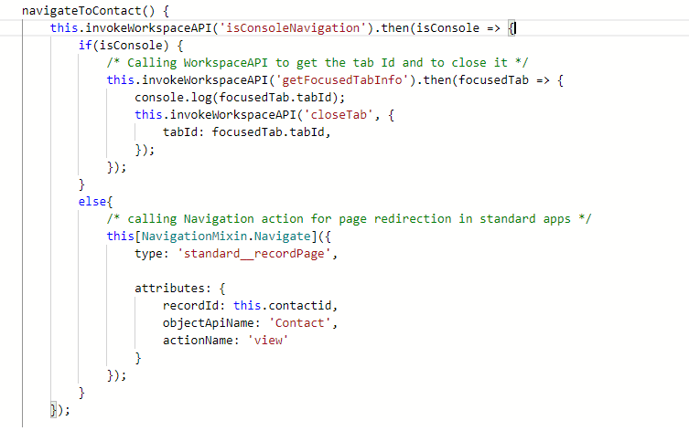

From this function we are calling a helper function in which we will generate a promise which will be utilized by Workspace API for further processing

In invokeWorksapcaAPI We are passing methodName as ‘isConsoleNavigation‘ and if the subtab will be open it will return the promise as true else false

isConsoleNavigation()

Returns a Promise. Success resolves to true if console navigation is present, false otherwise. The Promise will be rejected on error.

Based on the invokeWorkspaceAPI response we have a logic if subtab is open it will use workSpaceAPI else will use standard navigation setting

If the subtab is open it will go inside the if statement

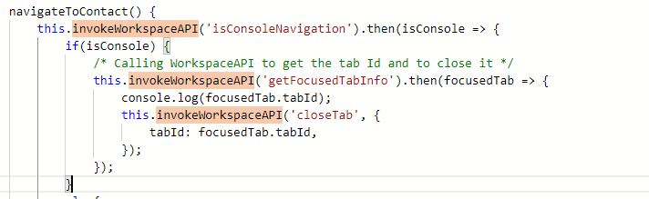

Where we will utilize getFocusedTabInfo to get the tab details and then use closeTab to close to close the sub tab

getFocusedTabInfo()

Returns a Promise. Success resolves to a tabInfo object. The Promise will be rejected on error.

closeTab({tabId})

* tabId (string): ID of the workspace tab or subtab to close.

Returns a Promise. Success resolves to true. The Promise will be rejected on error.